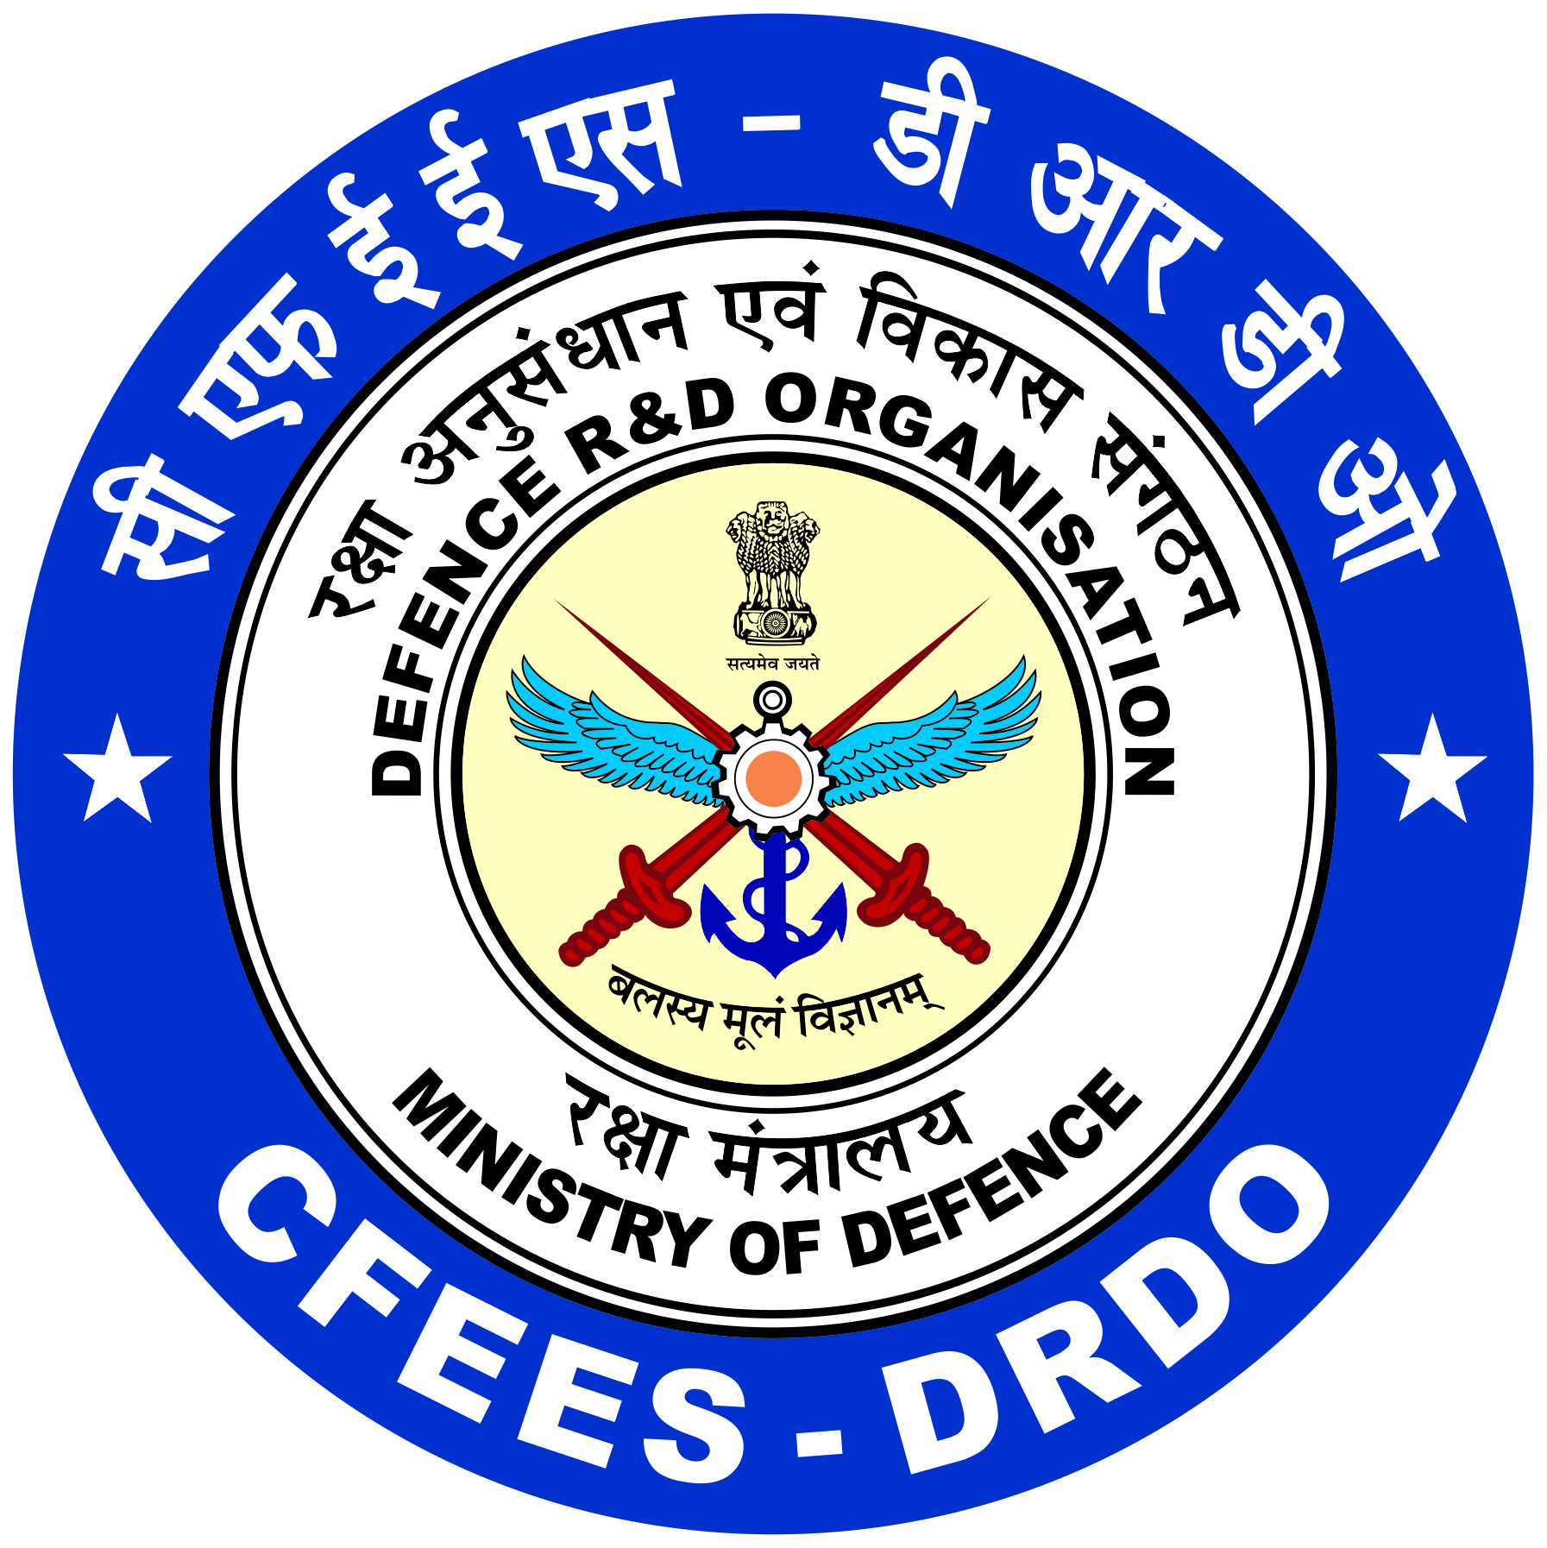

No. CFEES/HRG/V.TRG/CERTIFICATE/Year/
रक्षा मंत्रालय, डीआरडीओ
Min. of Defence, DRDO
अग्नि, विस्फोटक एवं पर्यावरण सुरक्षा केंद्र
Centre for Fire, Explosive & Environment Safety, (CFEES)
ब्रि. एस. के. मजूमदार मार्ग, तिमारपुर,

Brig. S. K. Mazumdar Marg, Timarpur
दिल्ली - ११० ०५४

Delhi - 110054
दिनांक: 05/07/2024

ISO 9001: 2015

CERTIFICATE

This is to certify that Mr. Suchin kumar, B.Tech. computer science and engineering, Roll no. 2110110524 of Shiv Nadar Institution of Eminence, Noida has undergone his 7 weeks training at Centre for Fire, Explosive and Environment Safety (CFEES), Defence Research & Development Organization (DRDO), Timarpur, New Delhi-110054 from the period 22/05/2024 to 05/07/2024. During this training, he worked on the topic “Development of HRD portal” under the guidance of Ms. Mamta Meena, Scientist ‘E’.
He was found to be sincere and hardworking during the training.
We wish him a great and successful future.

Head(QRS&IT) Associate Director (TCP&HR)
CFEES, DRDO CFEES, DRDO

